

AMERICAN INTERNATIONAL UNIVERSITY-BANGLADESH

COMPUTER GRAPHICS – PROJECT DOCUMENTATION

|  |  |
| --- | --- |
| **Course Name** | Computer Graphics |
| **Section** | B |
| **Course Tutor** | Md. Masum Billah |

**Group Members Information:**

|  |  |
| --- | --- |
| **Name** | **ID** |
| **Shobuz,Imran Sikder** | **18-38756-3** |
| **Name: Md Shakhawat Hossain Khan** | **14-26495-2** |
| **Name: MD. YEASIN MRIDHA** | **19-41801-3** |
| **Name: KAMAL, MOSTOFA** | **18-38342-2** |

**Table of Content:**

|  |  |
| --- | --- |
| **Content List** | **Page No** |
| Introduction | 03 |
| Proposal | 03 |
| Schematic Diagram | 04 |
| List of Objects | 04-06 |
| Functions to Represent the Objects | 06 - 08 |
| Interactive Functions | 09 |
| Task Assignment and Codes of Functions | 10-11 |
| Output | 12-14 |
| Conclusion | 14 |

**Introduction**

The project will demonstrate a minimal look of an Arabian day and night view, where we mainly focus on the Pyramid. We implemented a scenario of two views which are day and night. Without the Pyramid there will be a river and a lot of trees. All together it would render an eye pleasing desert scenario. Our program provides fast and accurate rendering of the objects. As well as a landscape to simulate a perfect desert view.

**Proposal**

The project about a scenario type. There will be a real life scenario about a Pyramid’s area view. There will be a Pyramid, tree, day, evening and night sky, river, a proper desert view. There will be some keyboard connection which will for moving different angle for more batter view.

**Schematic Diagram**

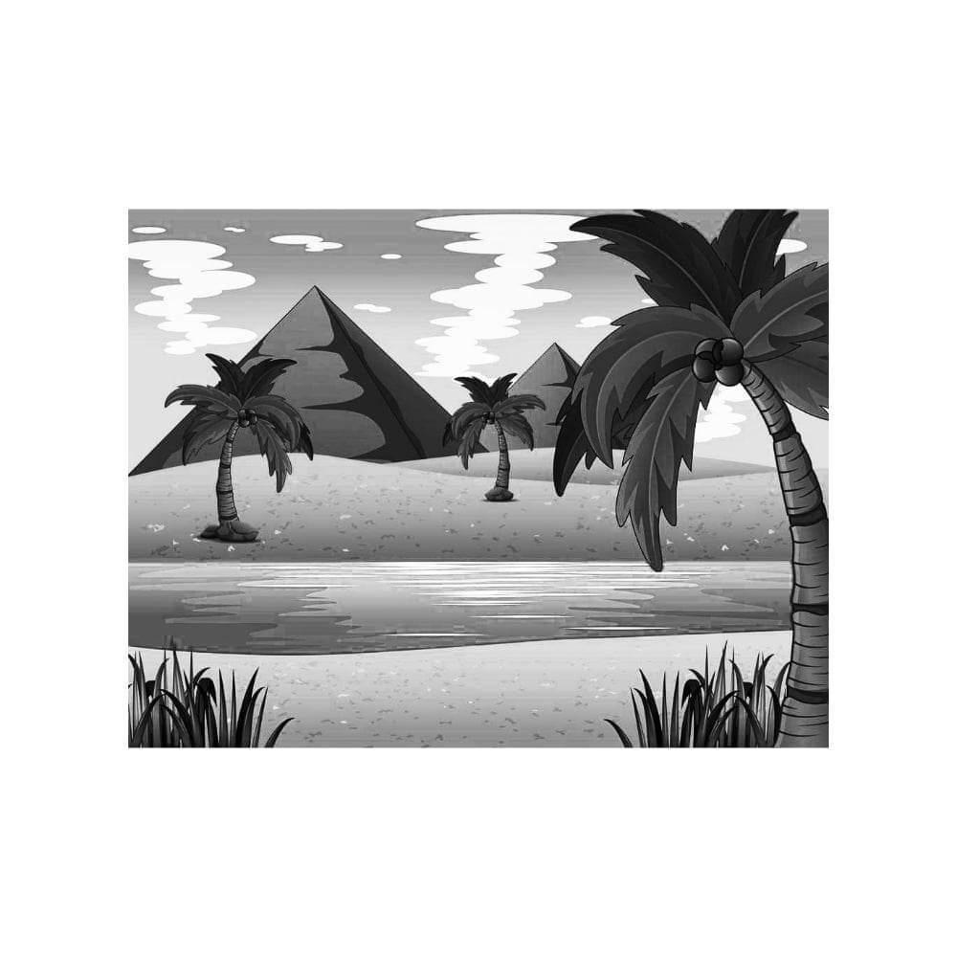

**List of Objects**

1. Desert sand
2. Pyramid
3. 3 Tree
4. Night sky
5. Day sky
6. Evening sky
7. Cloud
8. River waving

**Funtions to Represent The Objects**

|  |  |
| --- | --- |
| **Object** | **Function** |
| Pyramid | Void Pyramid() |
| Cloud | Void Cloud() |
| Tree | Void Tree() |
| River | Void River() |
| Desert | Void Desert() |
| Day sky | Void Day_sky() |
| Evening sky | Void Evening_sky() |
| Night sky | Void Night_sky() |

**Task Assignment and Codes of Funchtions**

**Contribution Table:**

|  |  |  |  |  |
| --- | --- | --- | --- | --- |
| **Member-1** | **Member-2** | **Member-3** | **Member-4** | **TOTAL** |
| 25% | 25% | 25% | 25% | 100% |

|  |  |
| --- | --- |
| **Name**  **ID** | **Contribution in Project** |
| **Member-1**  Name: Shobuz,Imran Sikder  Id: 18-38756-3 | 1. Desert 2. Tree |
| **Member-2**  Name: Md Shakhawat Hossain Khan  ID: 14-26495-2 | 1. Day sky 2. River |
| **Member-3**  Name: MD. YEASIN MRIDHA  Id: 19-41801-3 | 1. Pyramid 2. Cloud |
| **Member-4**  Name: KAMAL, MOSTOFA  ID: 18-38342-2 | 1. Evening sky 2. Night sky |

**OUTPUT**

|  |  |
| --- | --- |
| **Day View** |  |
| **Evening View** |  |
| **Night**  **view** |  |
| **River** |  |

**Conclusion**

We are building our project using a library function of code blocks named openGL. We create a Arabian desert view where there will be a Pyramid, River, Tree, Cloud, Sky. We have implemented an automatic view of Pyramid scenario where day, night and evening are automatically time lapsing. The color of the desert sand, Pyramid, River and other object is variable with the views of the scene. In future we would like to develop this project into a 3D architecture which can turn this into more eye soothing to the user.

**Reference:**

1.

2.